# SMARTINTERNZ INTERNSHIP DOCUMENTATION

**PROJECT TITLE:**

**UNCOVERING THE GAMING INDUSTRIES HIDDEN GEMS: A**

**COMPREHENSIVE ANALYSIS OF VEDIO GAME SALES**

# DONE BY

# P.Lalith Kumar Reddy

# M.Dheeraj

# M.Pawan sai

**S V College Of Engineering,**

**Kadapa.**

# INTRODUCTION

* In the fast-evolving landscape of entertainment, the gaming industry stands out as a dynamic and multifaceted realm that captivates millions across the globe. The project "Uncovering The Gaming Industry's Hidden Gems: A Comprehensive Analysis of Video Game Sales" embarks on a journey to unravel the intricate layers of this vibrant domain through a rigorous datadriven approach.

* With the aid of advanced visualization and analytical tools provided by Tableau, this project delves into the depths of video game sales data, seeking to unearth the lesser-known yet impactful facets that often remain concealed amidst the industry's prominent giants. By meticulously dissecting patterns, trends, and correlations within the dataset, the project aims to identify hidden gems in games that have quietly garnered substantial sales figures without occupying the limelight.

* Through a meticulous exploration of global sales figures, market trends, and genre preferences, the project seeks to shed light on the underappreciated successes that contribute significantly to the industry's overall landscape. The comprehensive analysis is designed to not only highlight the unsung heroes but also to provide valuable insights for industry stakeholders, enthusiasts, and analysts alike.

* As the gaming world continues to expand, this project aspires to celebrate diversity, innovation, and the unexpected triumphs that collectively shape the gaming industry. By employing Tableau's powerful tools, the project aspires to uncover valuable narratives that enhance our understanding of this dynamic sector, while also offering a testament to the potential of data analysis in revealing hidden treasures within complex datasets.

* In this analysis we are going to analyse the video game sales between 1980 and 2020 years.

* The Ideal aim of this analysis is to find the video games sales patterns.

# VISUALIZATION

**1.Introduction to Data Visualization:**

* Data visualization involves presenting information and data in a graphical format.
* Utilizing visual elements like charts, graphs, and maps, data visualization tools offer an accessible way to interpret trends, anomalies, and patterns within data.
* It serves as a valuable tool for presenting complex data to non-technical audiences in a clear and comprehensible manner.

**2.Importance in Data Analysis:**

* In the era of Big Data, data visualization tools and technologies are indispensable for analyzing vast datasets and facilitating data-driven decision-making.
* These tools help distill massive amounts of information into meaningful insights.

**3.Variety in Graphs and Parameters:**

* The project employs diverse graphs plotted with various parameters tailored to distinct contexts.
* These graphical representations enhance understanding and provide a visual perspective of the data's narrative.

**4.Visualization in Action:**

* The project showcases a compilation of visualizations, stories, and dashboards.
* These components synergistically explain and present the data analysis process and its outcomes.
* For a comprehensive overview, the provided demonstration link offers detailed insights into each plot, story, and dashboard.

**Technical Architecture:**

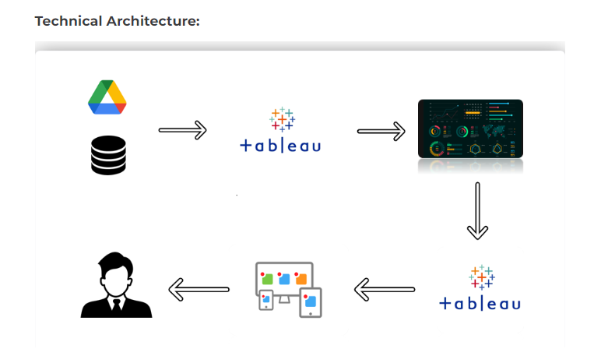

**Applications Required:**

MySQL Workbench:



Tableau Dashboard:

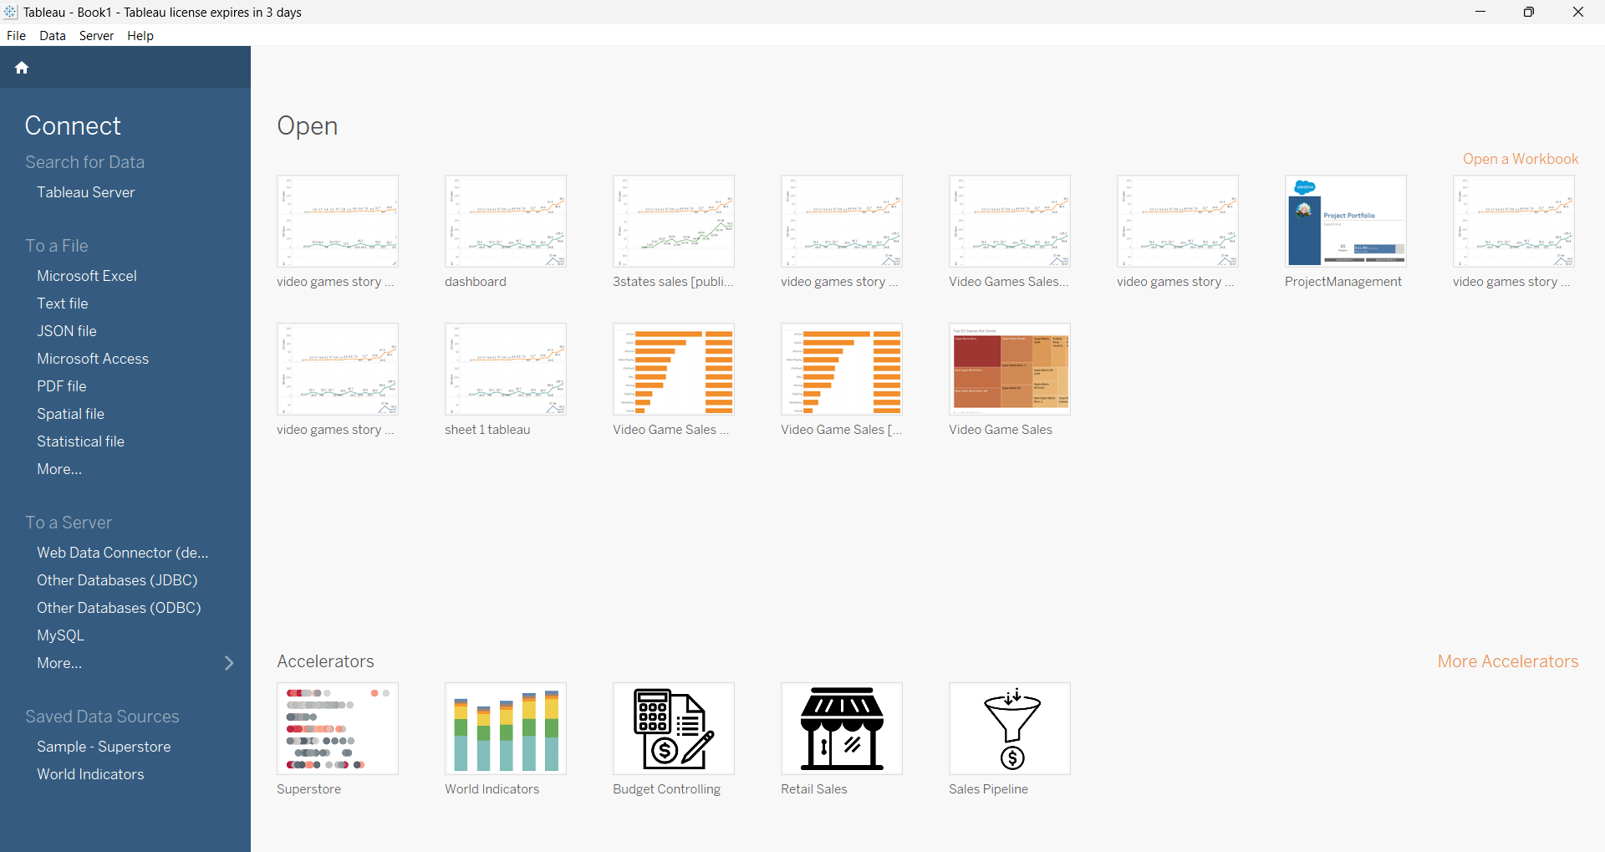

**Amount of data Rendered to Database:**



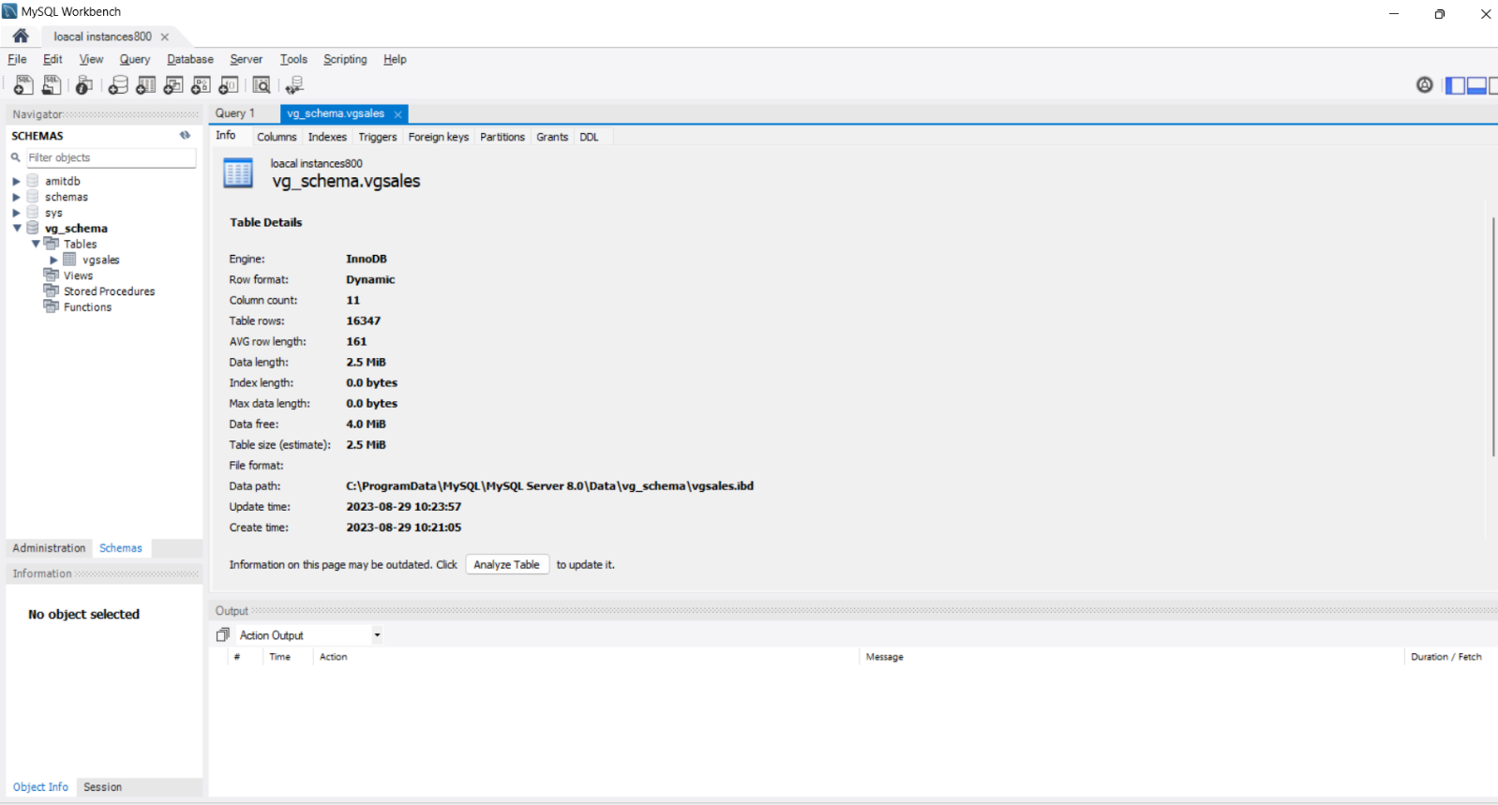

# DATASET

* Dataset plays a major role in doing Exploratory data analytics.
* To have a better result in your analytics, we should have the dataset to be cleaned. Cleaned in the sense, the data should not contain any noises in it. ➢ I have Took the dataset from Kaggle Website.

**LINK:**

https://www.kaggle.com/datasets/gregorut/videogamesales

# GRAPHS AND PLOTS

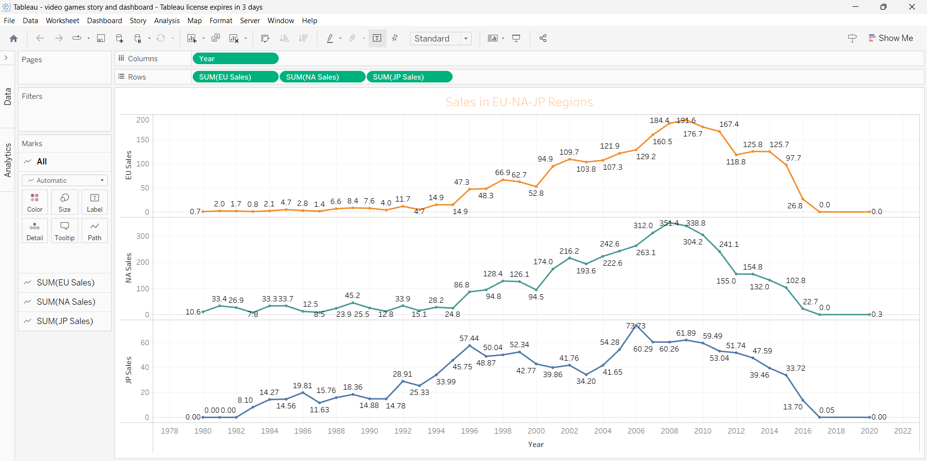

* Here in this we are using the line graph for the three different countries.
* EU Sales are high at the year 2009.
* NA Sales are high at the year 2008.
* JP Sales are high at the year 2006.

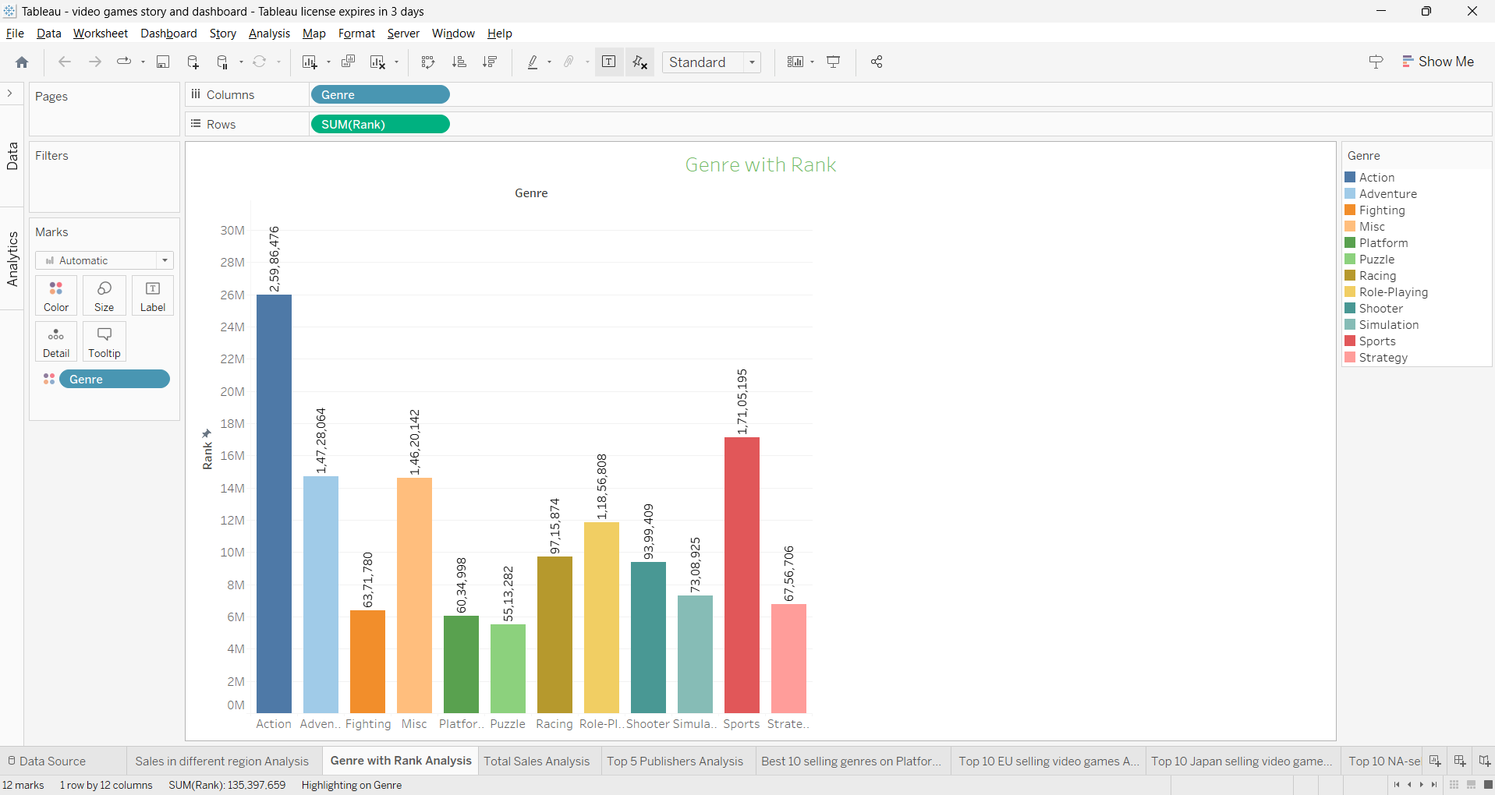

* Most of the game genres have majority of their sales in the region of North America and Europe.
* Action, Sports and Shooting games have got the majority market share. So, any startup looking to enter into market should firstly concentrate its effort on these genres
* Puzzle, Adventure and Strategy games have got the minority market share. So, these genres are to be avoided
* Role-Playing games have high sales potential in Japan. Any business looking to launch a game into this region is better off concentrating on this particular genre
* Japanese people do not seem to like Shooting and Racing games as is depicted in the sales. So, the companies are better off avoiding these genres when launching in the Japan region

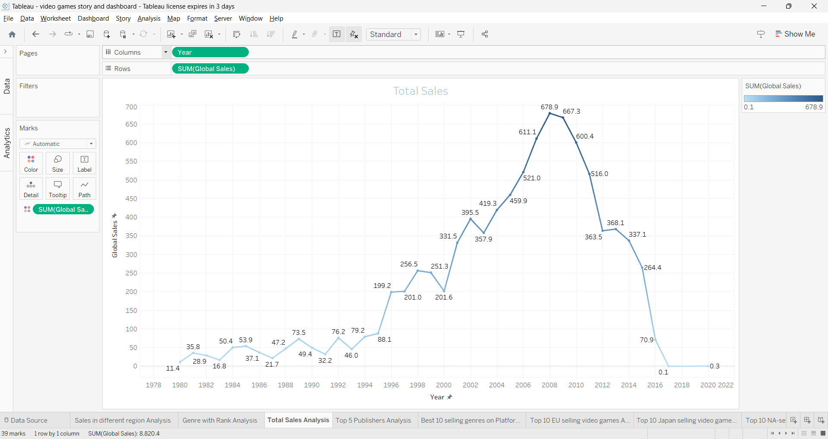

* Here in this we are analysing the total sales of the video games from the year 1978 to 2022.
* The sales are high at the year 2009 to 2012.
* In the year 2020 the sales are too low 0.3.

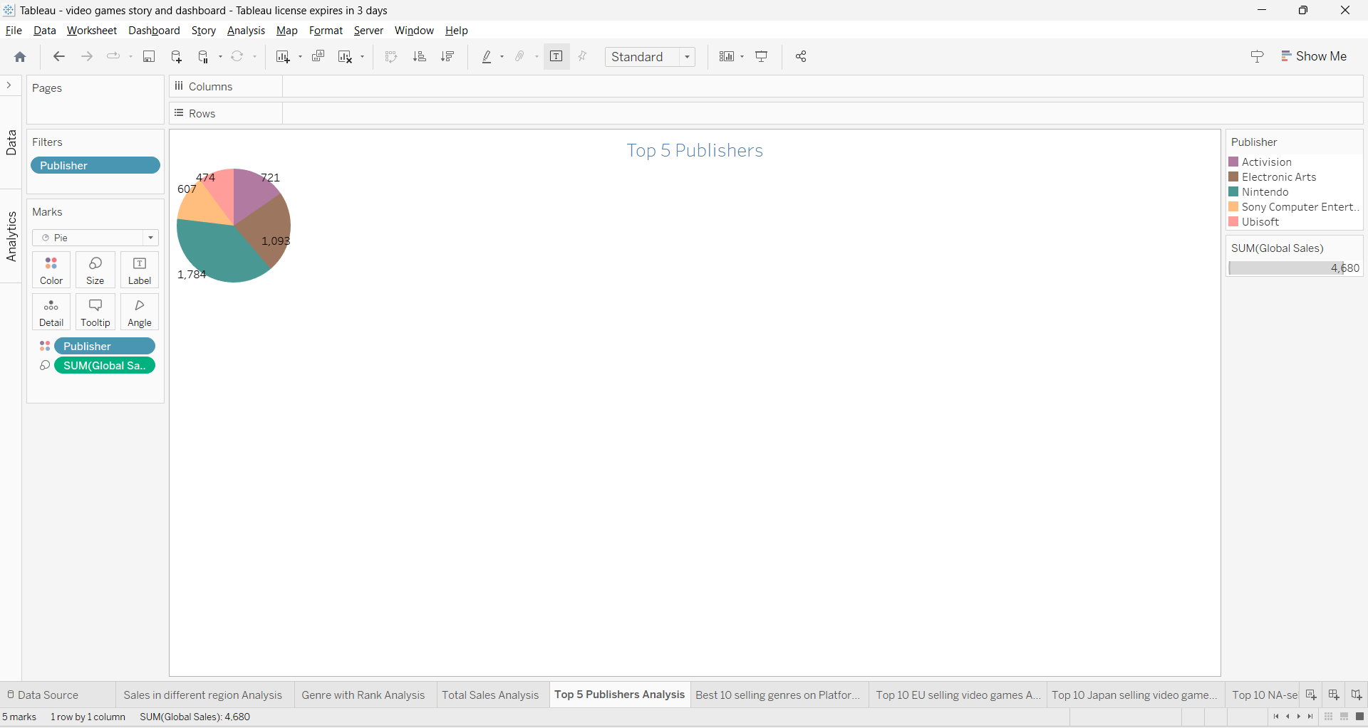

* Nintendo holds the biggest market share of the video games with most sales originating from North America followed by Japan, Europe and the rest of the world
* In the context of worldwide sales, Nintendo is followed by Electronic Arts, Activision, Sony and Ubisoft. Out of these four, only Sony has got the market share in Japan where the rest have the most sales generated from North America/Europe
* From the top 20 publishers, only 7 publishers have got the sales presence in Japan and the rest have almost NILL sales in that region. Seven publishers include Nintendo, Sony, Konami, Sega, Namco, Capcom and Square Enix. Other publishers are either failed to impress the Japanese gamers or not targeting the Japanese gaming market at all
* Namco and Konami have the most sales in Japan, even more than those of North America and Europe. This is an opposite of the trend followed by the other publishers. Both these publishers need to attract the gamers in North America and Europe as well to advance into the likes of Nintendo and Sony

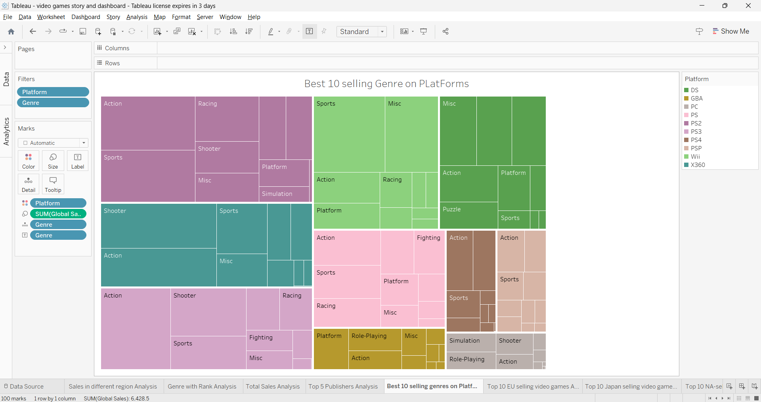

* The best 10 selling genre on platforms are the DS,GBA,PC,PS,PS2,PS3,PS4,PSP,WII,X360.

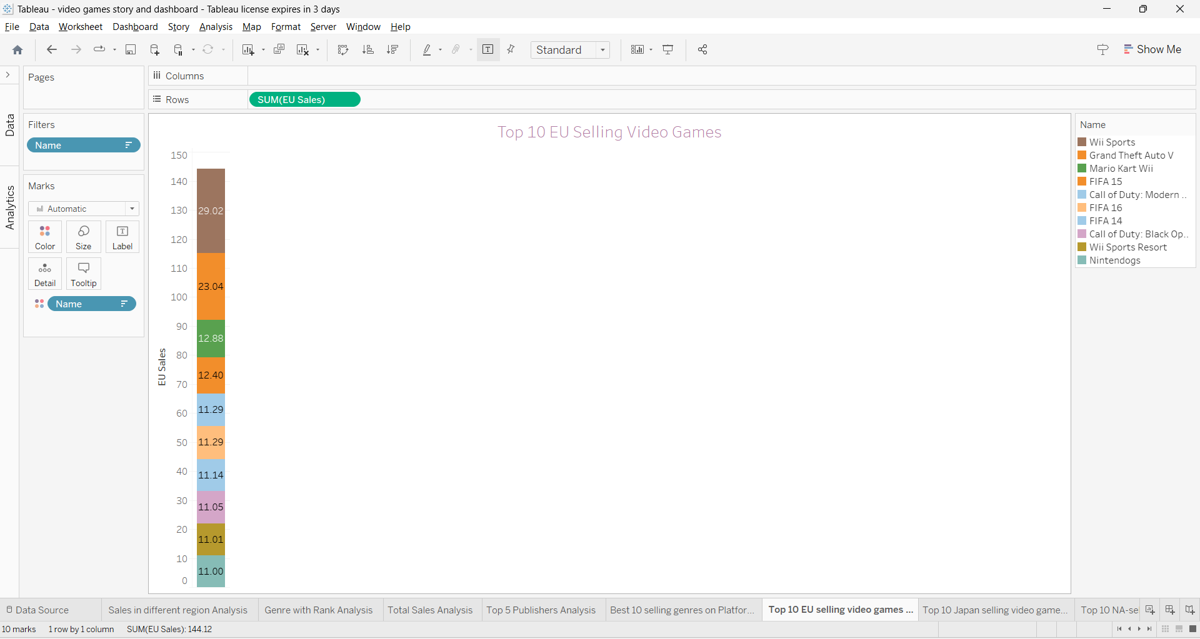

* Here is the top 10 EU selling video games.
* Top video games are Wii sports.
* The lowest video game sales are Nintendogs.

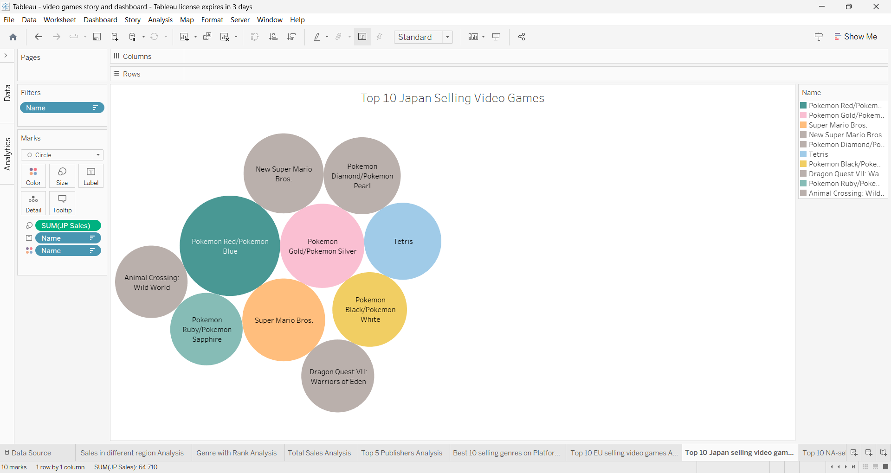

* Top 10 Japan Selling Video Games.
* Pokémon Gold/ Pokémon Silver is the highest sales in Japan

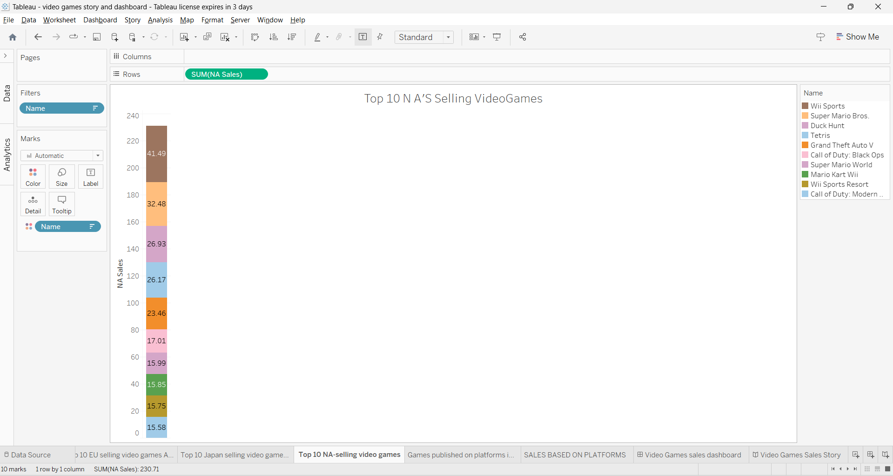

* Top 10 NA Selling Video games.
* Top video game is Wii Sports.
* Low video games is Call of Duty: Modern Warfare 3.

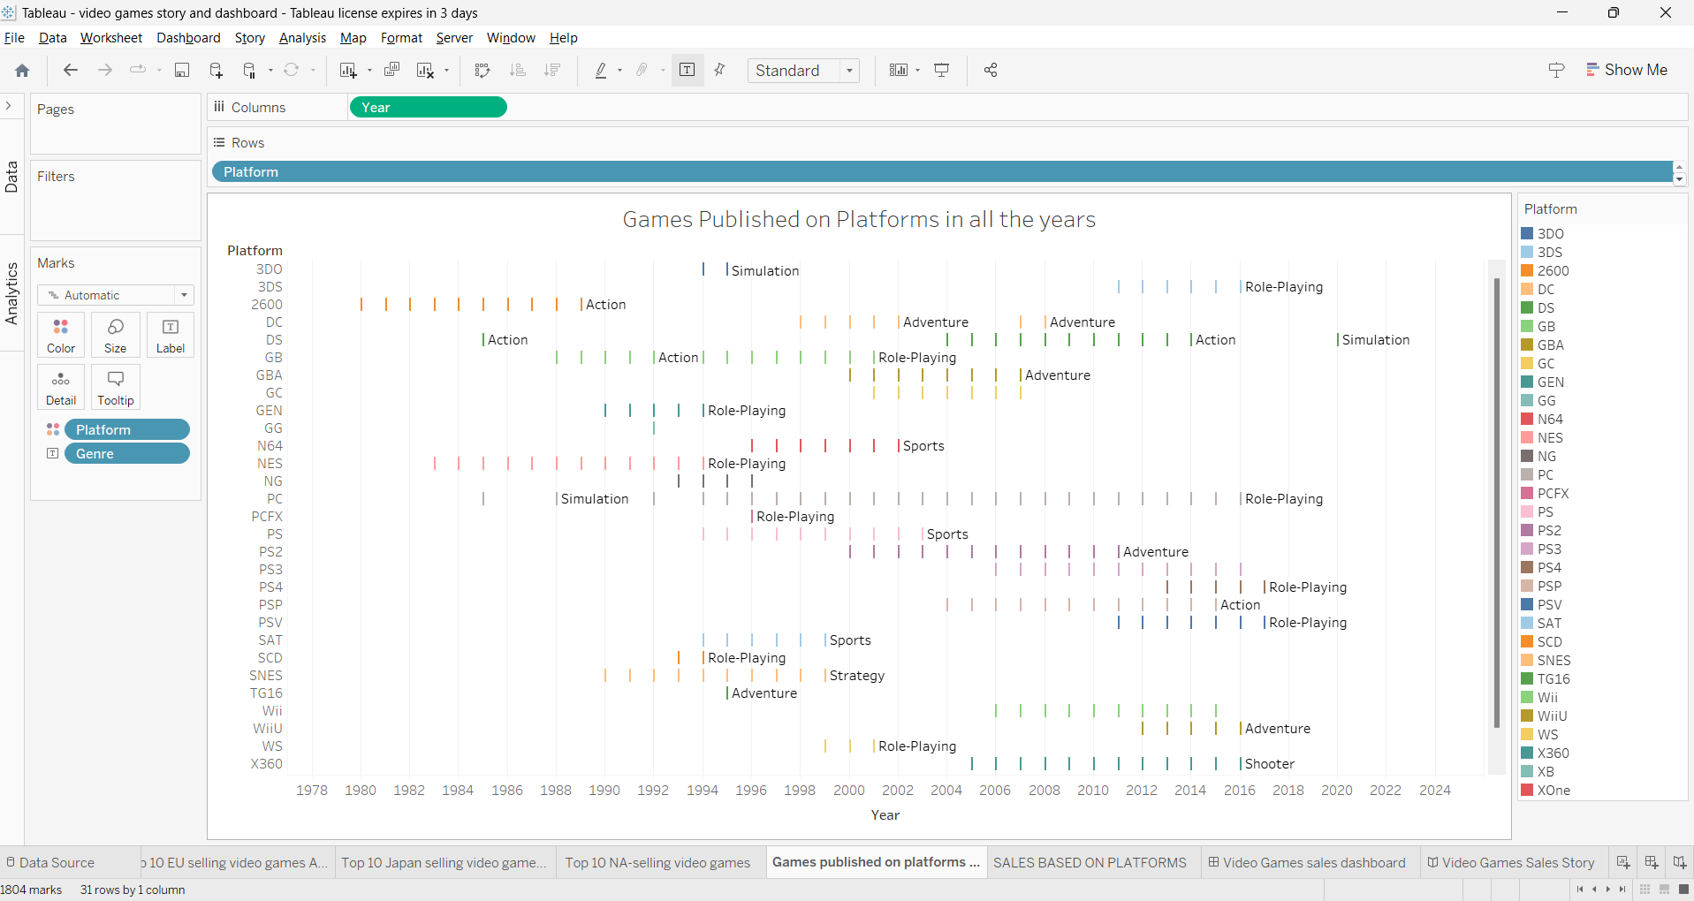

**DASHBOARD**

A dashboard in Tableau is a versatile tool that facilitates the simultaneous comparison of various data views.

1. **Purpose and Usage:** 
   * Dashboards allow users to consolidate multiple visualizations into one display for effective data exploration.
   * Instead of navigating to separate worksheets, users can access a collection of views all at once within a dashboard.
   * Useful for regularly reviewed sets of views, streamlining analysis routines.

1. **Access and Connection:** 
   * Dashboards are accessed from tabs at the bottom of a Tableau workbook, similar to how worksheets are accessed.
   * Data in both sheets and dashboards are interconnected. Changes made in one affect the other.
   * Modifications to sheets or dashboards reflect the latest available data from the connected data source.

1. **Features and Components:** 
   * Dashboards offer various features to create charts and visuals, enhancing data representation.

1. **Filters:** 
   * Filter actions allow users to refine displayed data, focusing on specific information.
   * Filters assist in presenting valuable insights by trimming down data to userdefined criteria.
   * For instance, a filter can be employed to show data related to a particular district rather than an entire state or region.

1. **Highlight Actions:** 
   * Highlight actions direct attention to specific data points, emphasizing them while dimming others.
   * Users can execute highlight actions in different ways, such as using legends, highlighter, or advanced actions.
   * This feature is helpful for pinpointing significant data points within a visualization.

1. **URL Actions:** 
   * URL actions enable hyperlinks to external web pages or embedded web elements within the dashboard.
   * Useful for seamlessly integrating additional information from external sources directly within the dashboard.

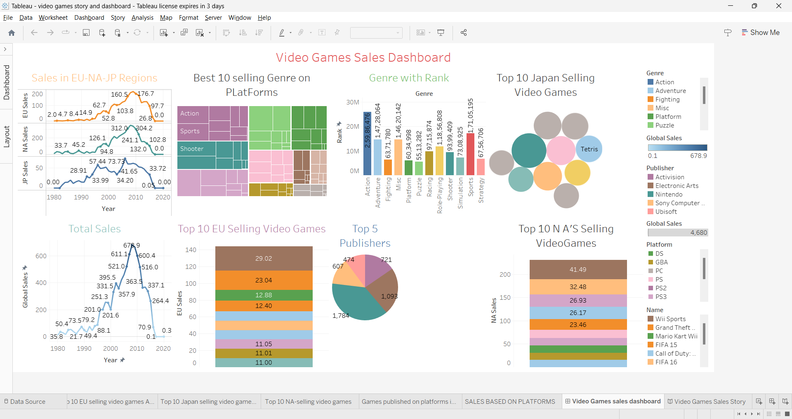

Link:

https://public.tableau.com/views/videogamesstoryanddashboard/VideoGamessalesdashboard?:language=en-US&:display_count=n&:origin=viz_share_link

# STORIES

**Story:**

* A story in Tableau is a cohesive sequence of interactive visualizations and dashboards that are combined to convey a data-driven narrative. It allows users to present and share insights effectively by structuring a series of visual elements that guide viewers through a data analysis process.
* A story typically includes multiple sheets, dashboards, and sometimes textbased explanations to provide context and interpretation. This arrangement aids in highlighting patterns, trends, and relationships in the data.
* The interactive nature of a Tableau story empowers users to engage with the visualizations, enabling a comprehensive understanding of the data story being presented.
* A story is a sheet, so the methods you use to create, name, and manage worksheets and dashboards also apply to stories (for more details, see workbook and sheets).

**Tableau Public story link:**

https://public.tableau.com/views/videogamesstoryanddashboard/VideoGamessalesdashboard?:language=en-US&:display_count=n&:origin=viz_share_link

**STORY SCREENSHOTS**

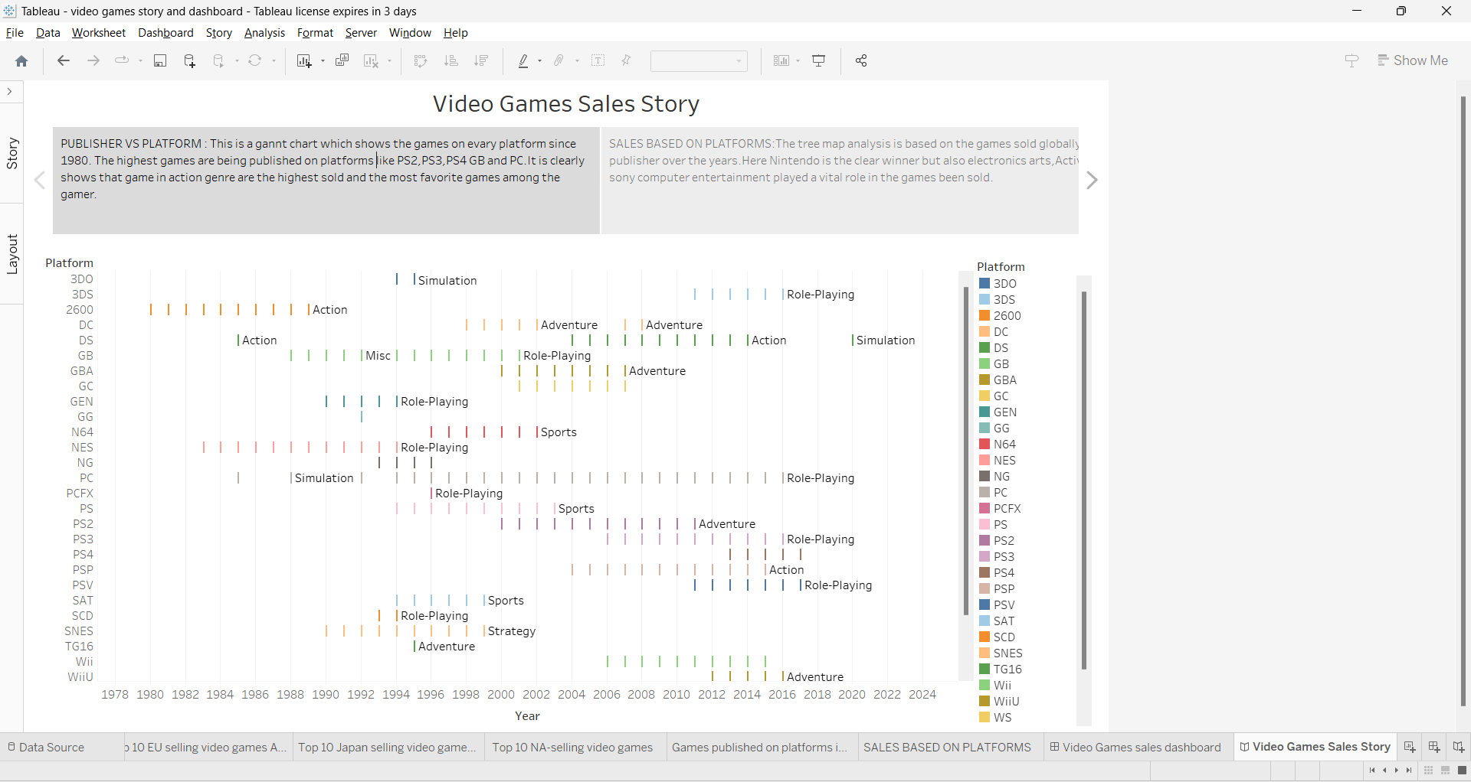

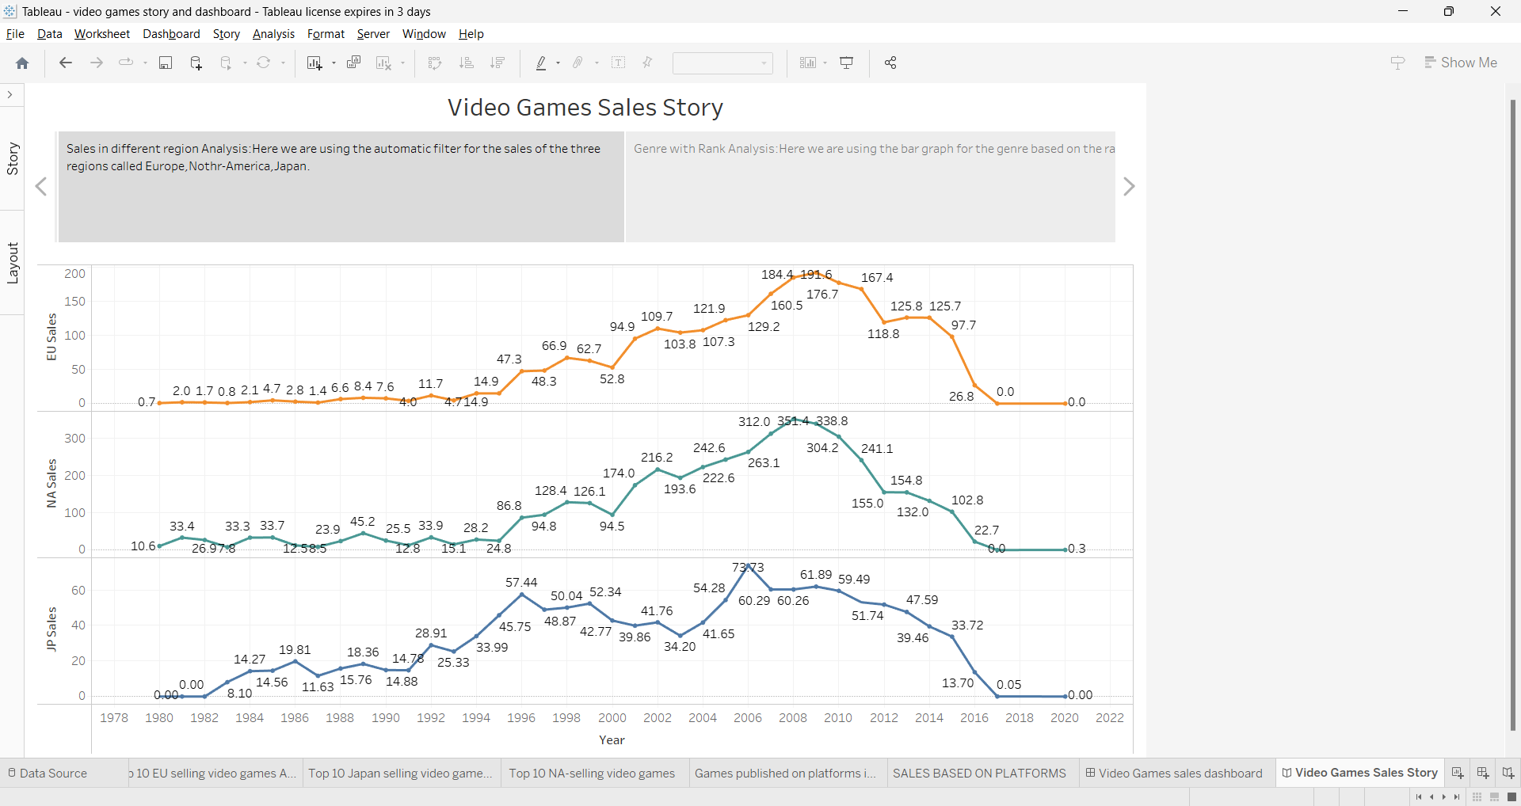

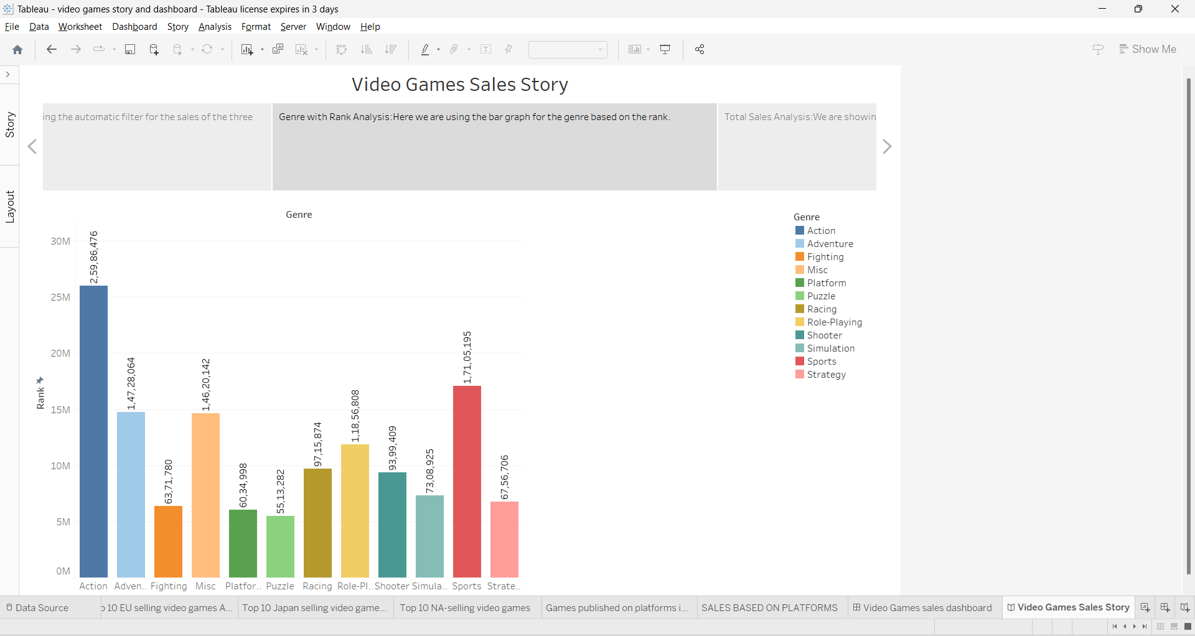

**APPLICATIONS:**

* + - * Decide Technology.
      * Making social friendly games.
      * Versatility of games
      * Final on online community.

# CONCLUSION

**Video game sales based on Genre:**

* Action is the highest-selling genre both in terms of sum and average.

However, the average top-selling genre is Platform.

* Sports ranks as the second highest-selling genre in sum, while Shooter takes the second spot for average sales.
* Shooter secures the third position for highest sales in sum, with RolePlaying claiming that spot in terms of average sales.
* Strategy emerges as the least sold genre both in terms of sum and average, while Adventure occupies the same position for average sales.

**Video game sales based on Platform:**

* NES leads as the top-selling platform.
* WII stands as the second highest-selling platform.
* GBA secures the third position among platforms in terms of sales.
* 3DS represents the platform with the least sales.

**Video game sales based on Publisher:**

* Nintendo holds the position of the highest-selling publisher.
* Sony Computer Entertainment ranks second in terms of publisher sales.
* Sega occupies the third position in the list of top-selling publishers.
* Virgin Interactive is the least performing publisher in terms of sales.

**Video game sales based on Games:**

* Super Mario Bros claims the top spot as the most sold game.
* New Super Mario Bros takes the second position in terms of sales.
* New Super Mario Bros Wii secures the third position in terms of sales.
* Super Mario Galaxy 2 has the lowest sales among the listed games.

**Video game sales based on Years:**

* The year 2000 records the highest sales.
* In 2005, sales take the second spot.
* Sales in 1995 secure the third position.
* The year 2015 represents the period with the lowest sales.

**Video game sales based on Region:**

* North America leads in sales among regions.
* Europe ranks as the second highest-selling region.
* Other Countries represent the region with the least sales.